Chanakya Capital Services Pvt Ltd Factsheet

Portfolio Performance* as on Sep 30th , 2026 – (Returns for periods over 1 year are annualized (TWRR))
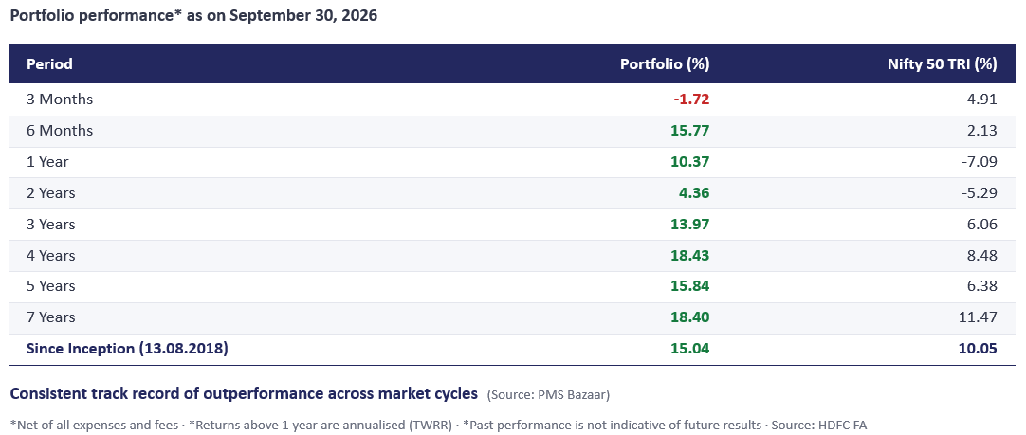
Sector Weights as on Aug 31st, 2026 (%)
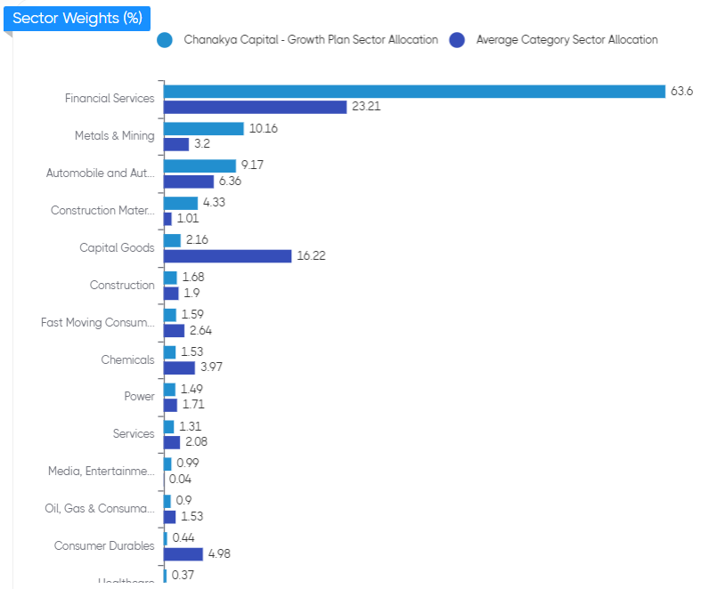

Market Cap Composition as on Aug 31st, 2026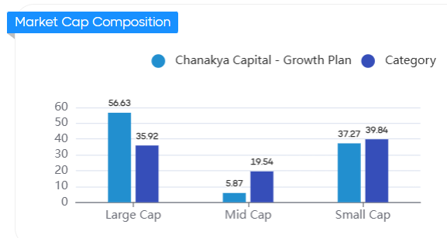

Our Top Holdings as on Sep 30th , 2026 (77%)
Script Name | Weights %
AXIS Bank Ltd | 18%
Bajaj Holdings & Investment Ltd | 9%
Karur Vysya Bank Ltd | 8%
Samvardhana Motherson International Ltd | 7%
HDFC Bank Ltd | 7%
South Indian Bank Ltd | 7%
Shriram Finance Ltd | 5%
Ramco Industries Ltd | 4%
Steel Authority of India Ltd | 4%
Tata Steel Ltd | 4%
City Union Bank Ltd | 4%

